**E-Commerce Supplement Factory Home Page**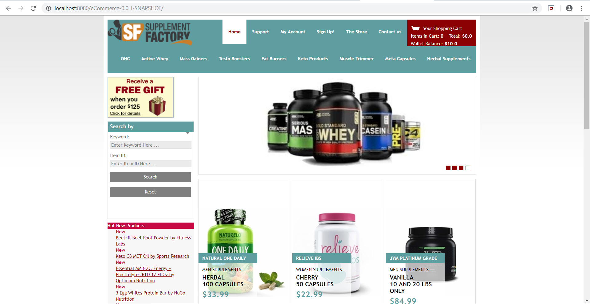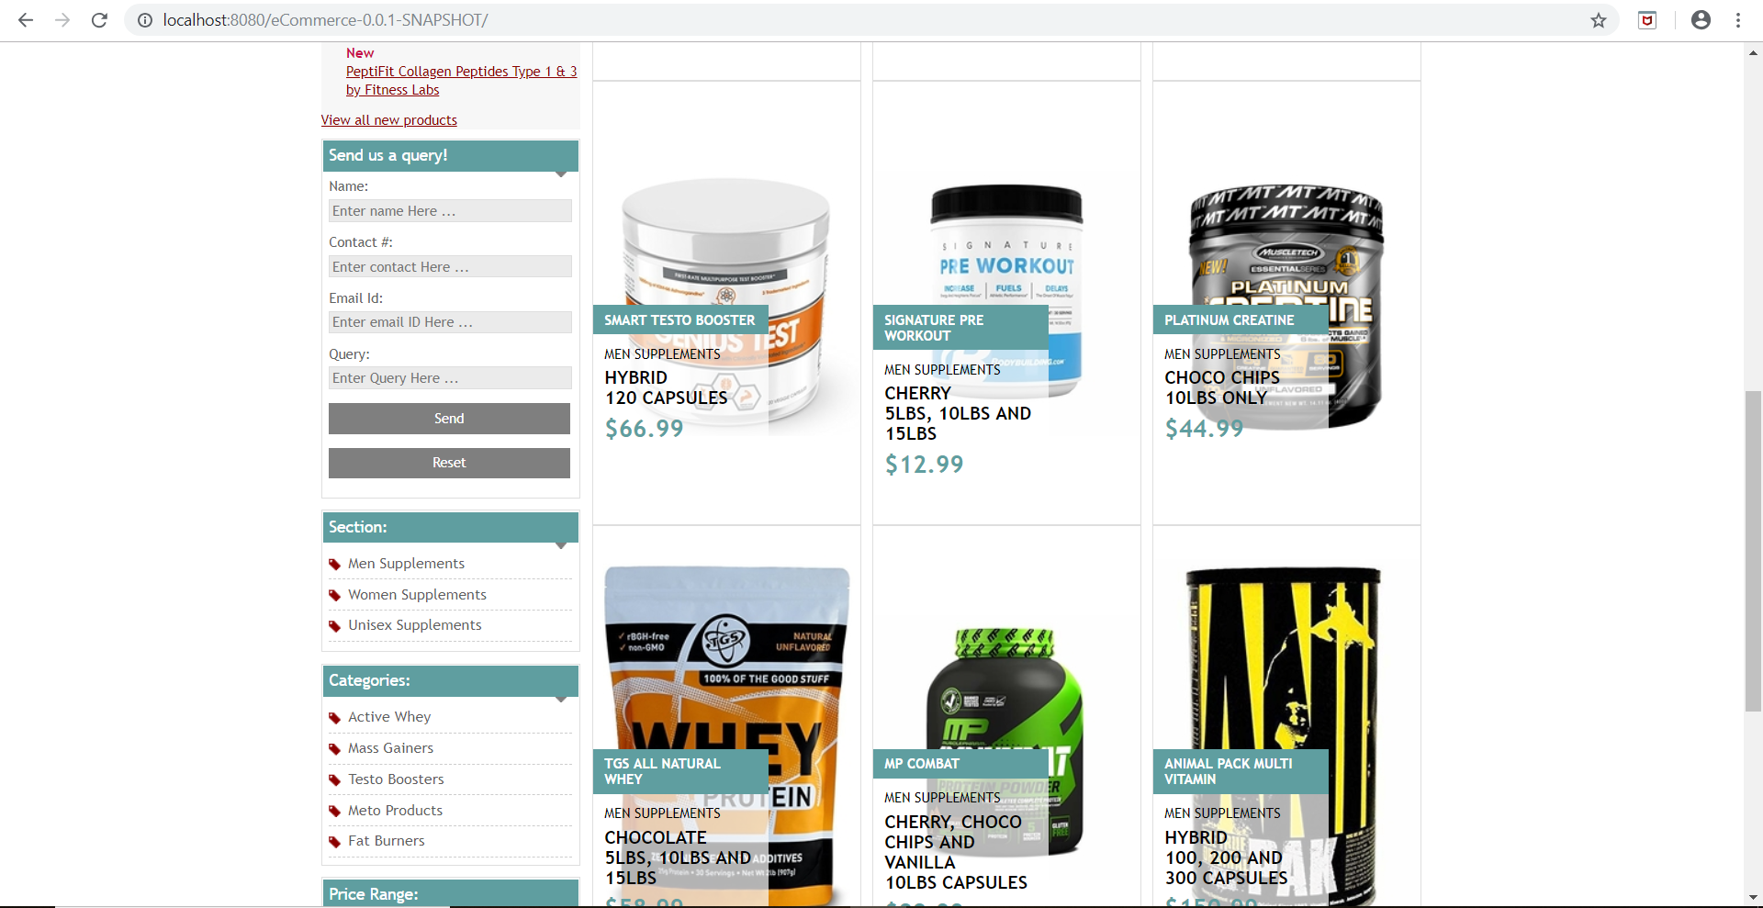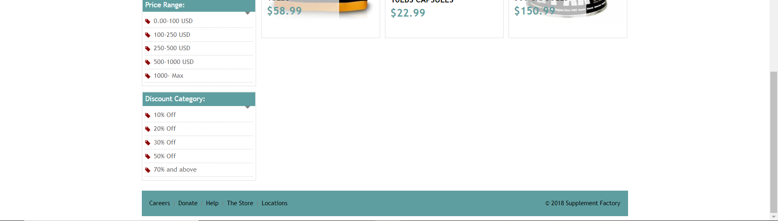

**Keyword search (Text Search)**

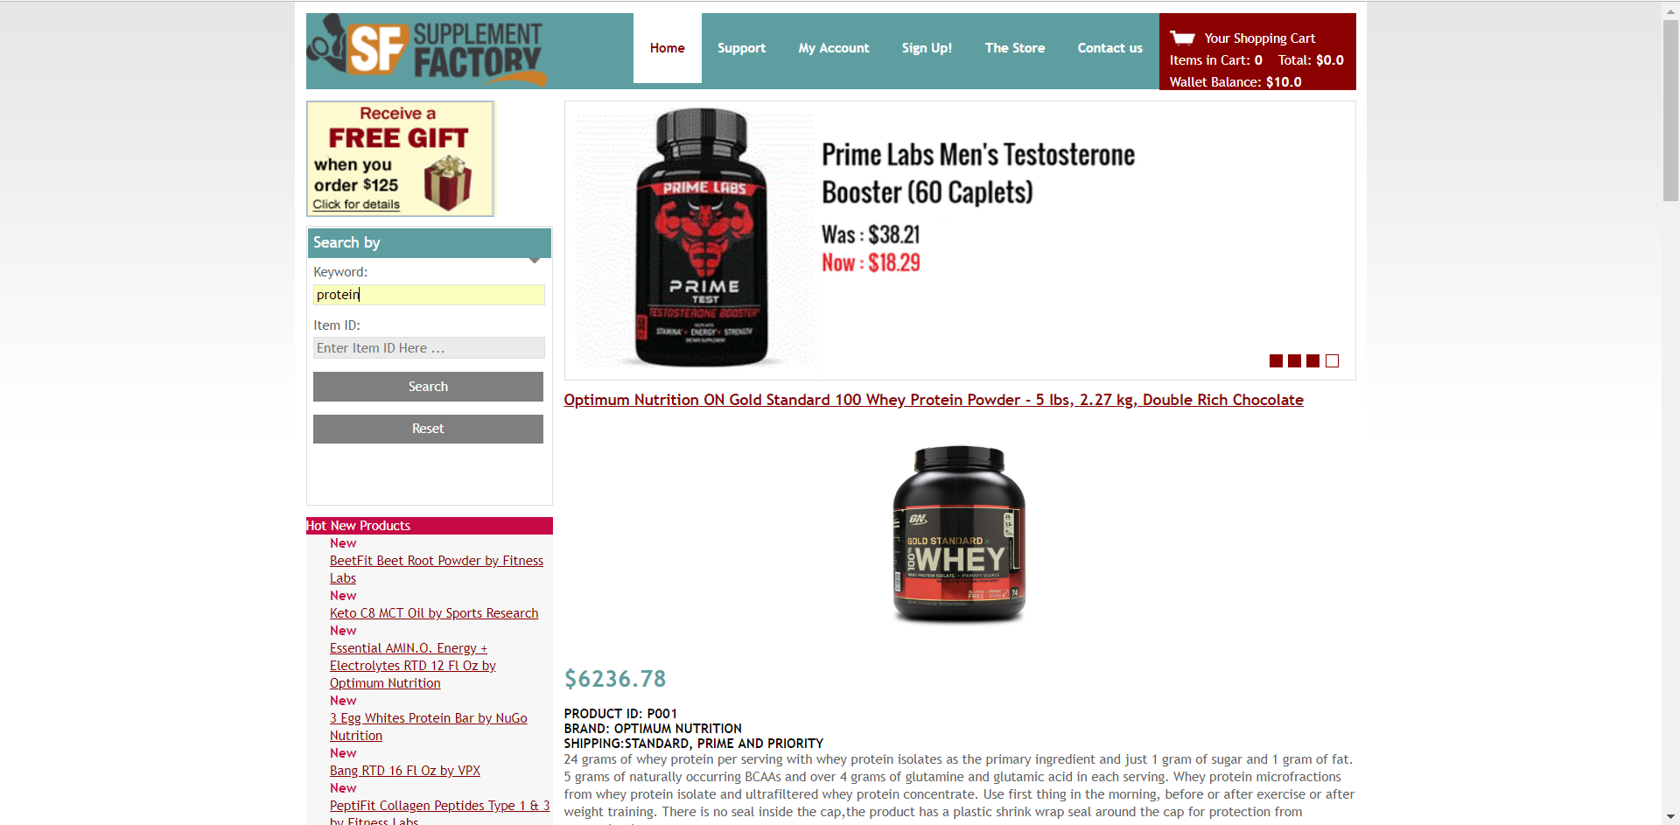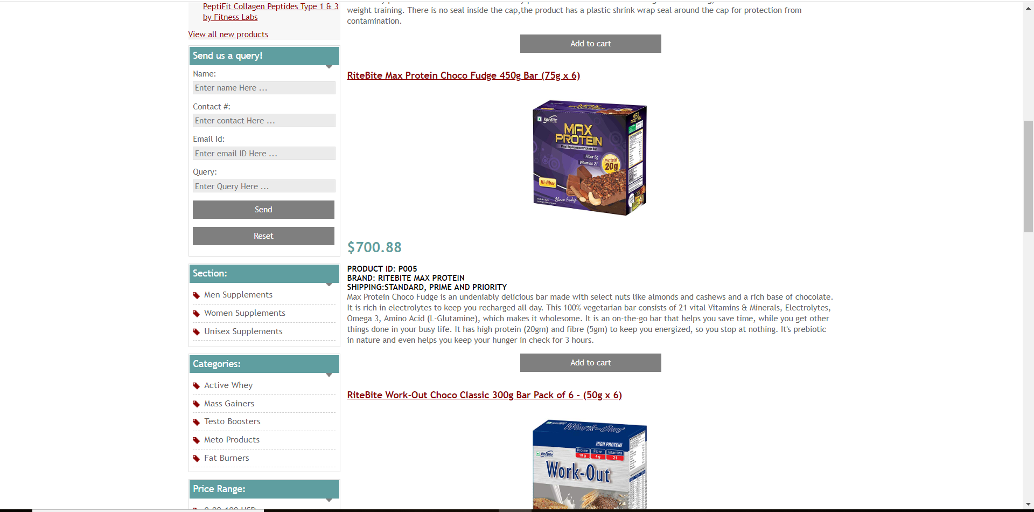

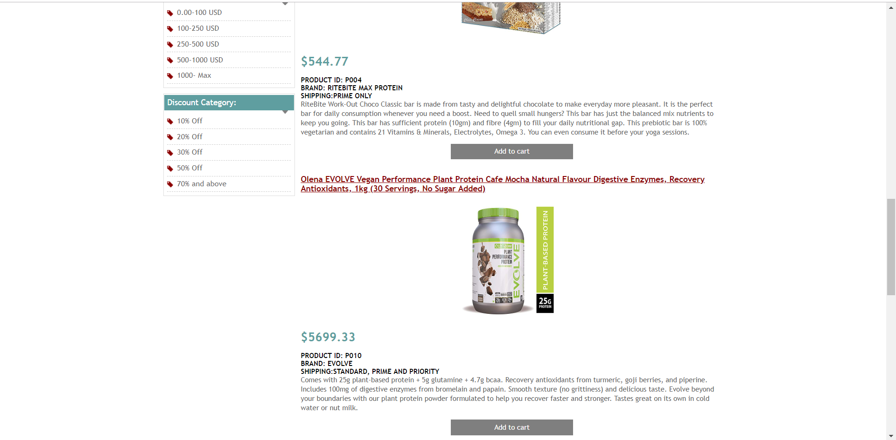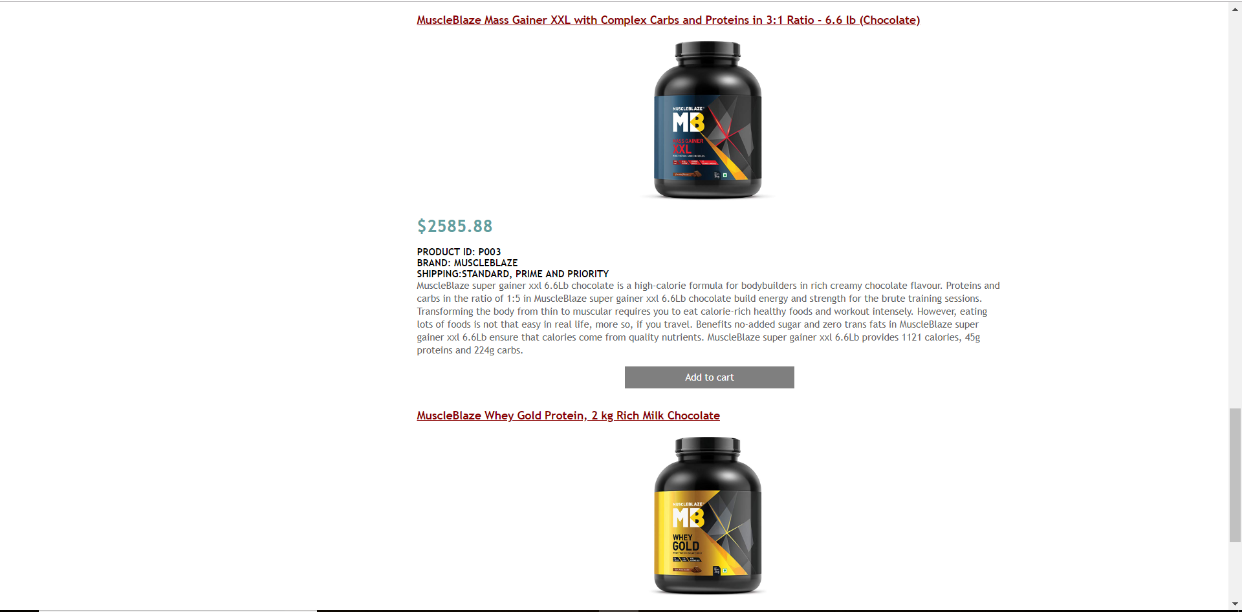

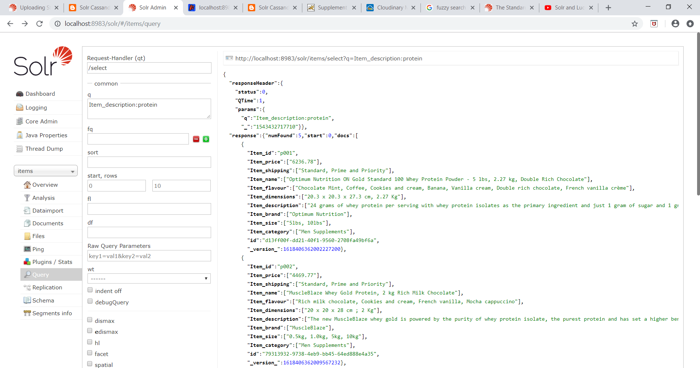 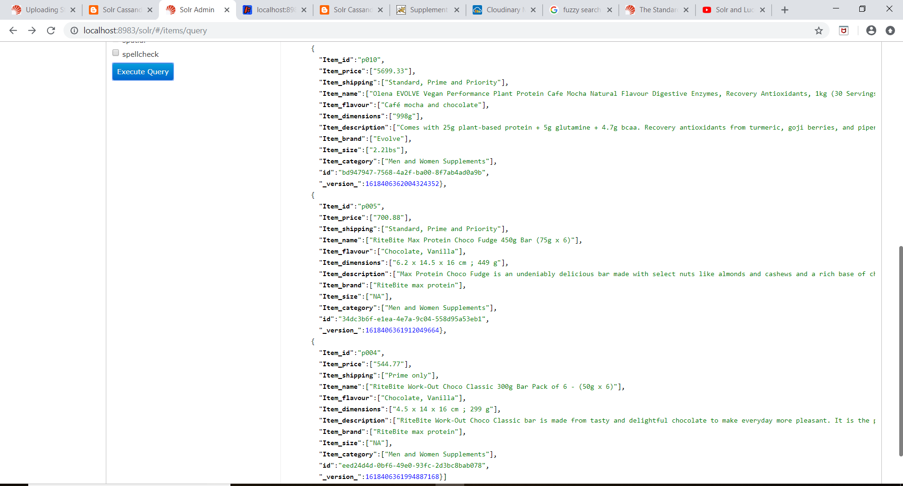

**Item ID Search**

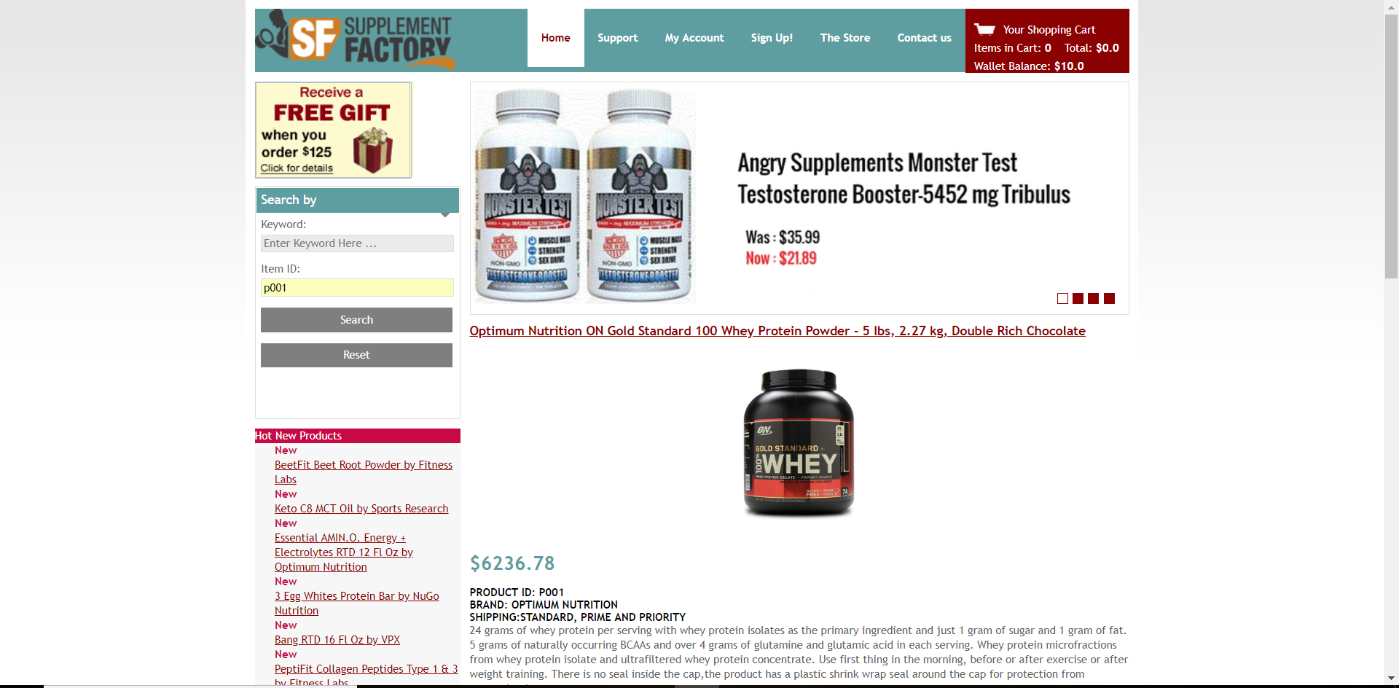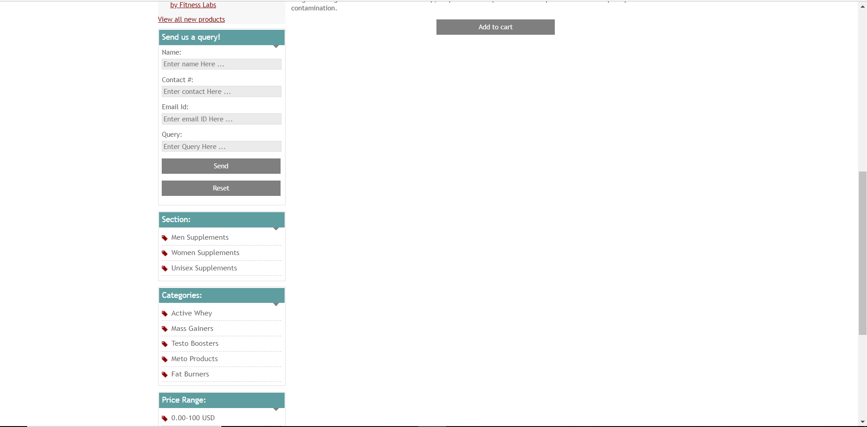

**Full text search with document boosting:** **Item_shipping:(Prime~0.75 AND only~0.75)**

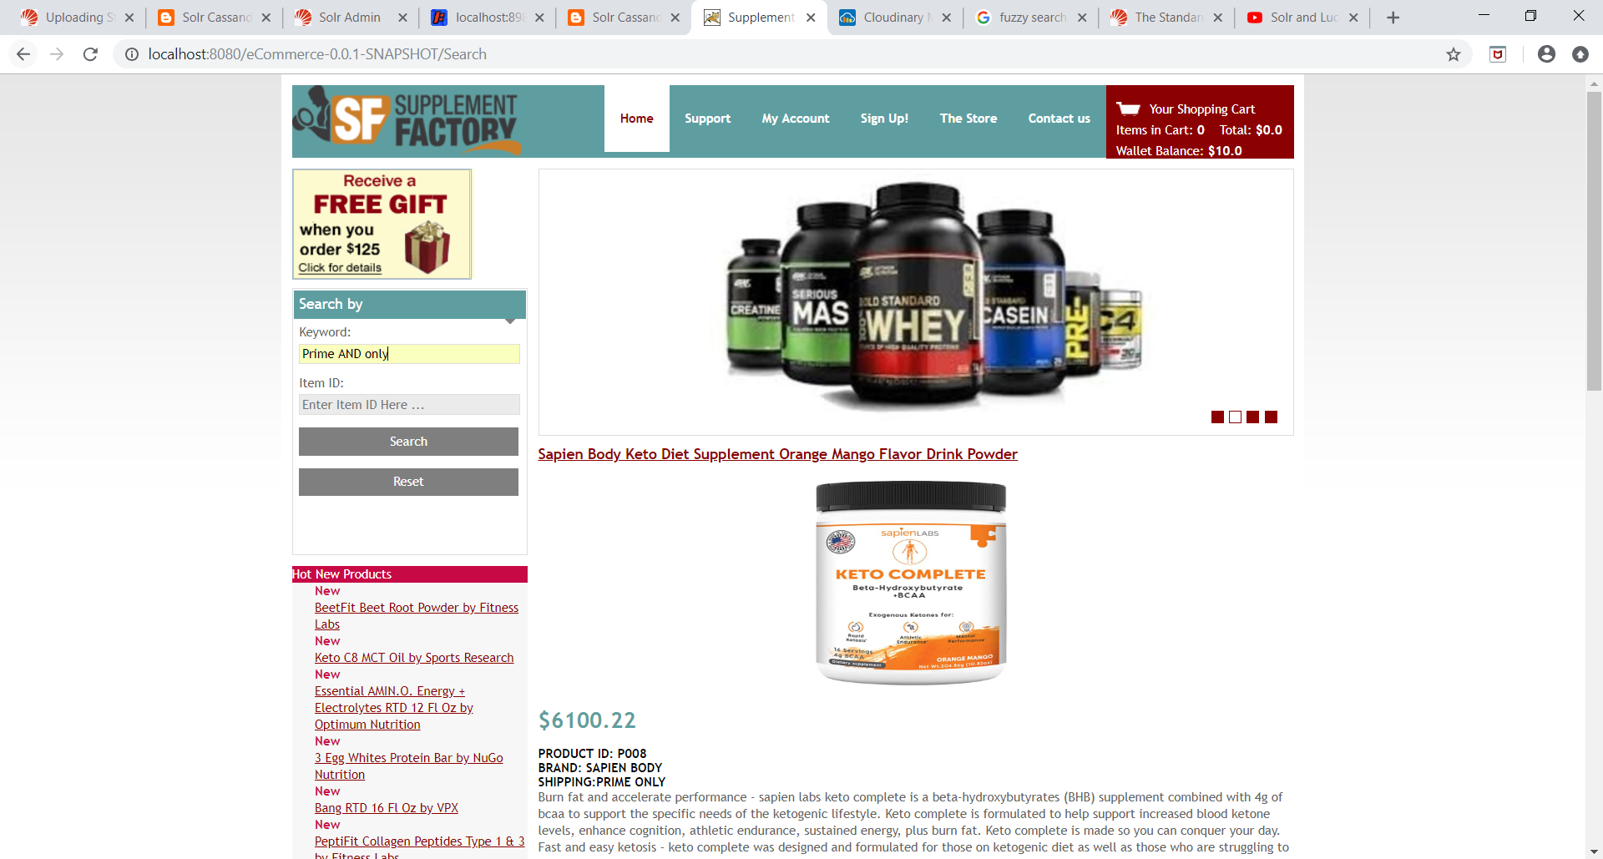 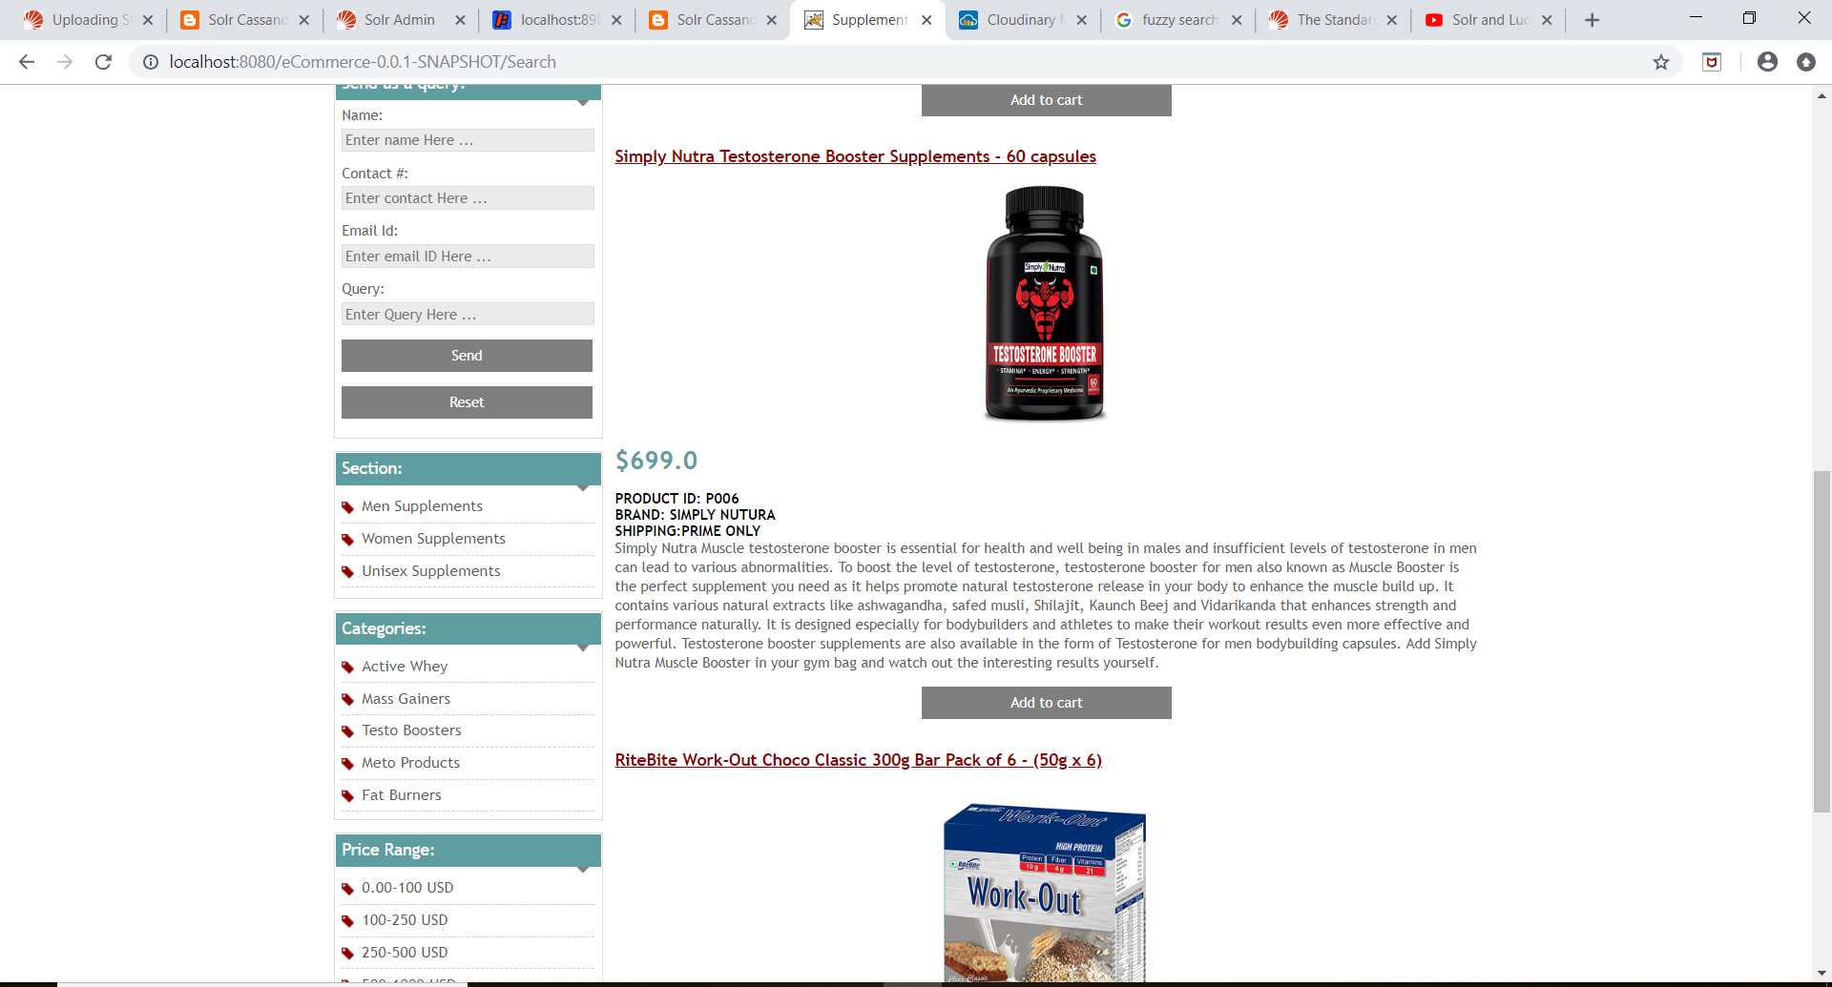

**Fuzzy Search:** **Item_shipping:(Pime~1 AND only~0.8)**





**Architecture**

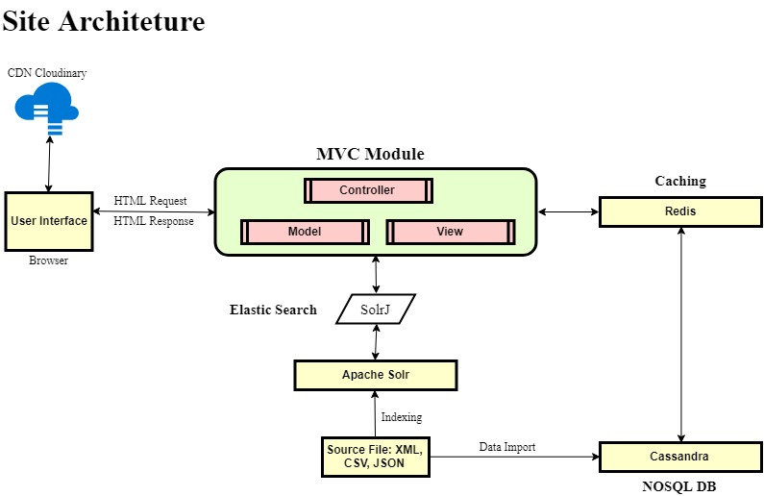

**Control and Process flow**

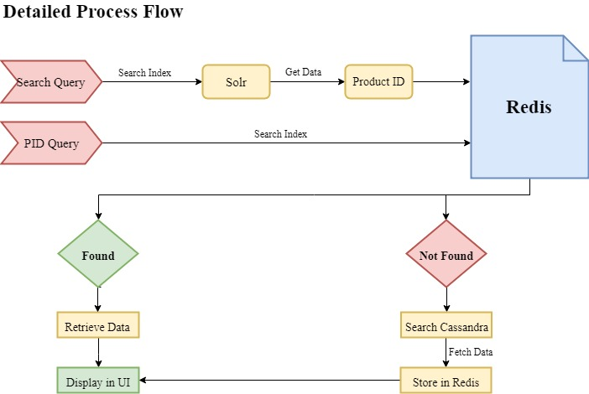

**Back End – Cassandra**

**Keyspace: ecommerce Connected to localhost at 127.0.0.1 Table(Column family): items**

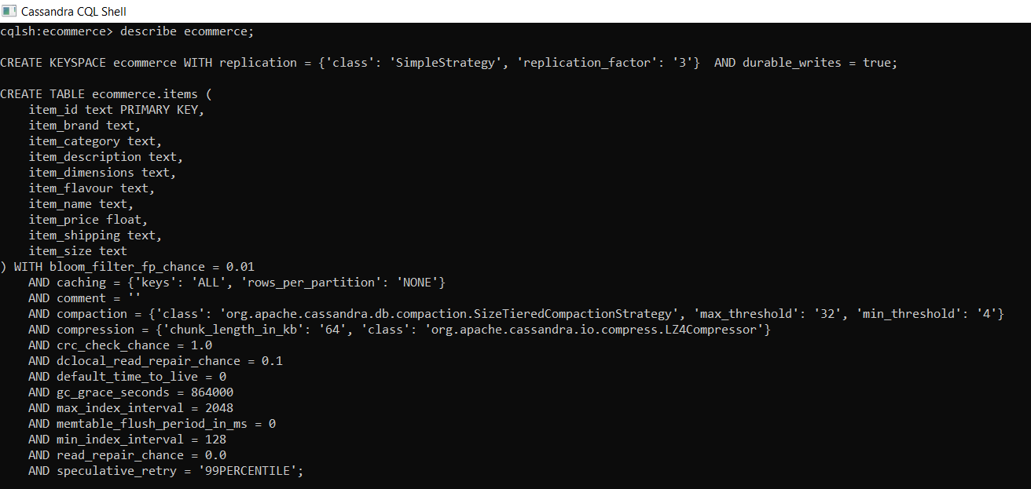



Source Data for data load: Finaldata.txt is used to load the data into Cassandra items table (column family).

**Cassandra statements for schema creation and data load:**

CREATE KEYSPACE ecommerce WITH replication = {'class':'SimpleStrategy', 'replication_factor': '3'} AND durable_writes = true;

CREATE TABLE items

(Item_id text PRIMARY KEY,

Item_name text,

Item_brand text,

Item_category text,

Item_price float,

Item_shipping text,

Item_size text,

Item_flavour text,

Item_dimensions text,

Item_description text

);

COPY items (Item_id, Item_name, Item_brand, Item_category, Item_price, Item_shipping, Item_size, Item_flavour, Item_dimensions, Item_description) FROM 'finaldata.txt' WITH DELIMITER='|' AND HEADER=TRUE;

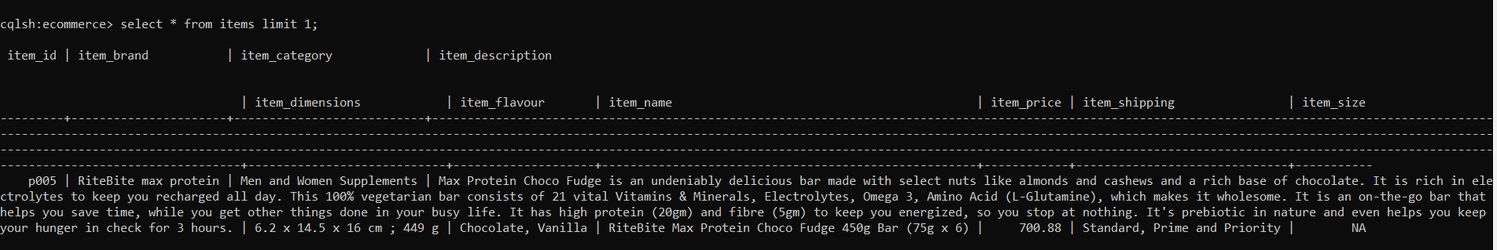

Solr is used to index on Cassandra table items and below are files and commands used to configure Solr for Casandra as DIH.

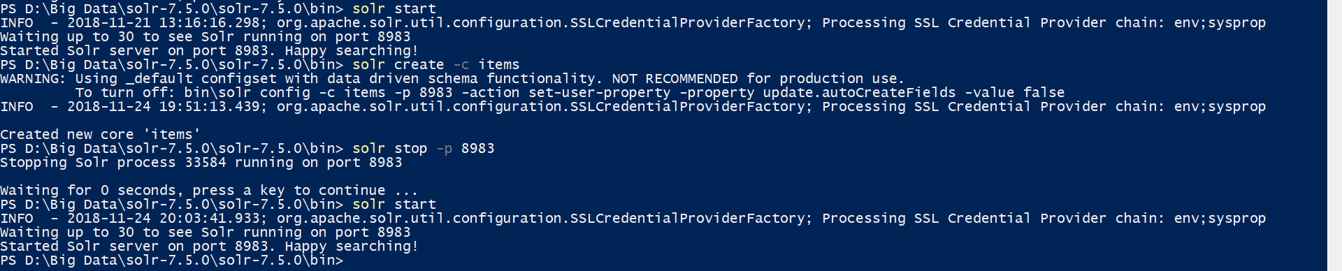

Start Solr- Solr start

Create a Solr core- Solr create -c <core name> Eg- Solr create -c items

**dataconfigCassandra file:**

<dataConfig>

<dataSource type="JdbcDataSource"

driver="org.apache.cassandra.cql.jdbc.CassandraDriver"

url="jdbc:cassandra://127.0.0.1:9160/ecommerce"

autoCommit="true"/>

<document name="content">

<entity name="ecommerce"

query="SELECT Item_id, Item_name, Item_brand, Item_category, Item_price, Item_shipping, Item_size, Item_flavour, Item_dimensions, Item_description from items" autoCommit="true">

<field column="Item_id" name="Item_id" />

<field column="Item_name" name="Item_name" />

<field column="Item_brand" name="Item_brand" />

<field column="Item_category" name="Item_category" />

<field column="Item_price" name="Item_price" />

<field column="Item_shipping" name="Item_shipping" />

<field column="Item_size" name="Item_size" />

<field column="Item_flavour" name="Item_flavour" />

<field column="Item_dimensions" name="Item_dimensions" />

<field column="Item_description" name="Item_description" />

</entity>

</document>

</dataConfig>

**Changes in Solrconfig.xml:**

<!--added for cassandra-->

<lib path="D:/Big Data/solr-7.5.0/solr-7.5.0/dist/cassandra-jdbc-1.2.5.jar" />

<lib path="D:/Big Data/solr-7.5.0/solr-7.5.0/dist/solr-dataimporthandler-7.5.0.jar" />

<lib path="D:/Big Data/solr-7.5.0/solr-7.5.0/dist/cassandra-clientutil-1.2.5.jar" />

<lib path="D:/Big Data/solr-7.5.0/solr-7.5.0/dist/cassandra-driver-core-3.3.0.jar" />

<!--<lib path="D:/Big Data/solr-7.5.0/solr-7.5.0/dist/cassandra-jdbc-driver-0.6.4.jar" />-->

<lib path="D:/Big Data/solr-7.5.0/solr-7.5.0/dist/cassandra-all-3.11.1.jar" />

<lib path="D:/Big Data/solr-7.5.0/solr-7.5.0/dist/cassandra-thrift-3.11.1.jar" />

<lib path="D:/Big Data/solr-7.5.0/solr-7.5.0/dist/libthrift-0.9.2.jar" />

<lib path="D:/Big Data/solr-7.5.0/solr-7.5.0/dist/solr-dataimporthandler-extras-7.5.0.jar" />

<!--added for cassandra-->

<!--added for cassandra-->

<requestHandler name="/dataimport" class="org.apache.solr.handler.dataimport.DataImportHandler">

<lst name="defaults">

<str name="config">dataconfigCassandra.xml</str>

</lst>

</requestHandler>

<!--added for cassandra-->

**ManagedSchema.xml:**

<!--Added for cassandra -->

<field name="Item_id" type="string" indexed="true" stored="true" required="true" />

<field name="Item_name" type="text_general" indexed="true" stored="true" required="true" />

<field name="Item_brand" type=" text_general " indexed="true" stored="true" required="true" />

<field name="Item_category" type=" text_general " indexed="true" stored="true" required="true" />

<field name="Item_price" type=" text_general " indexed="true" stored="true" required="true" />

<field name="Item_shipping" type=" text_general " indexed="true" stored="true" required="true" />

<field name="Item_size" type=" text_general " indexed="true" stored="true" required="true" />

<field name="Item_flavour" type=" text_general " indexed="true" stored="true" required="true" />

<field name="Item_dimensions" type=" text_general " indexed="true" stored="true" required="true" />

<field name="Item_description" type=" text_general " indexed="true" stored="true" required="true" />

<!--Added for cassandra -->



Once these configurations are in place, we can test our Solr indexing. Import the data from cassandra for indexing.



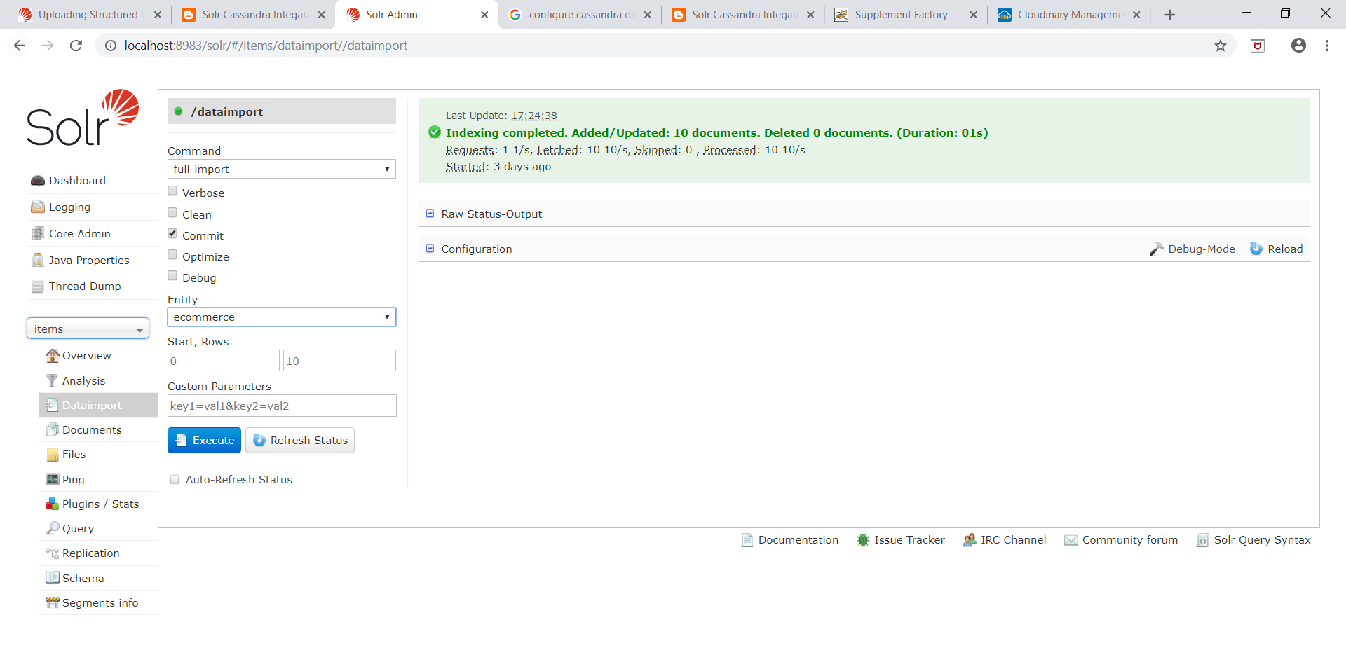

Test the indices

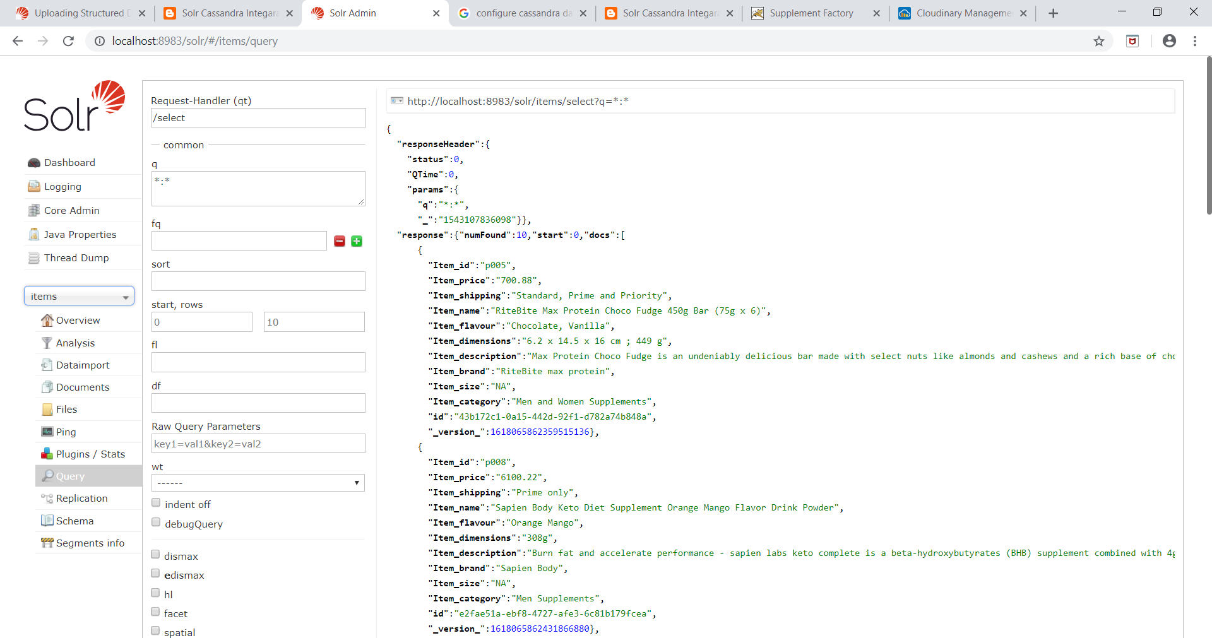

Dashboard:

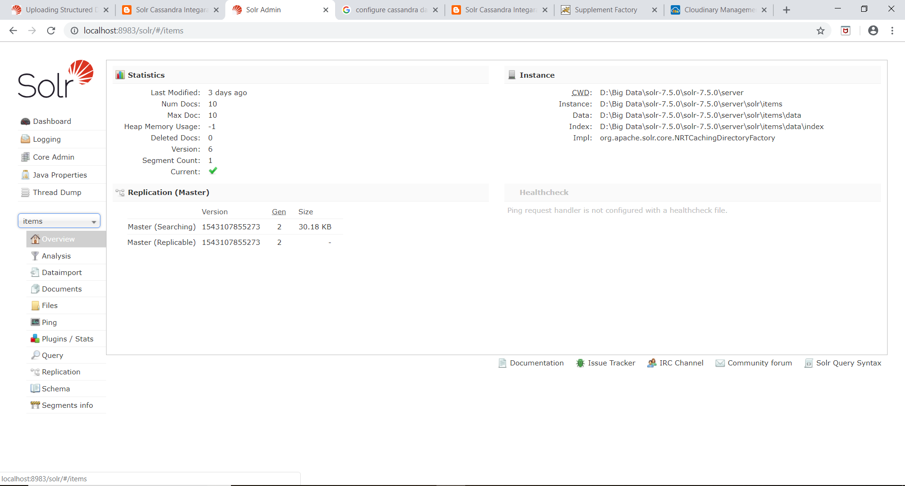

Cloudinary:

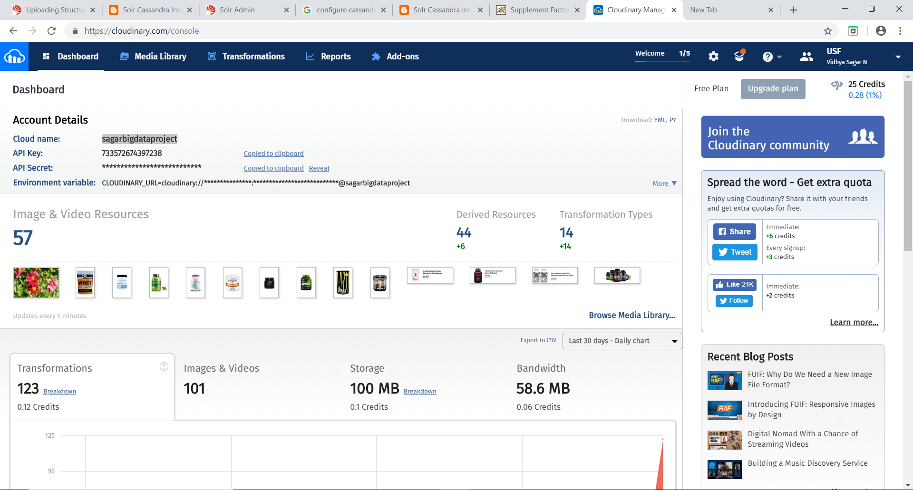

References:

1)Stackoverflow

2)Solr Documentation

3)Cassandra Documentation

4)W3 schools

5)Redis Documentation